Software Engineering Practice

USER – STORIES

Seán Murphy’s – User Story
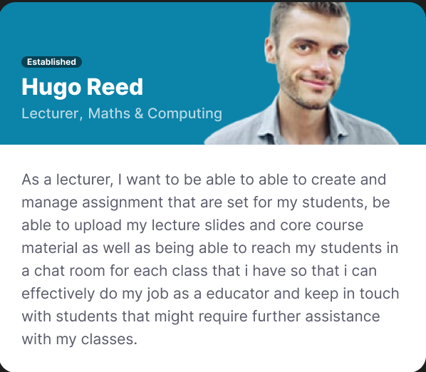

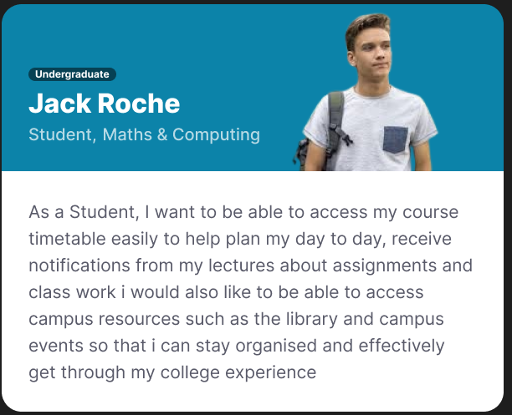

Alan Zaharia – User Story

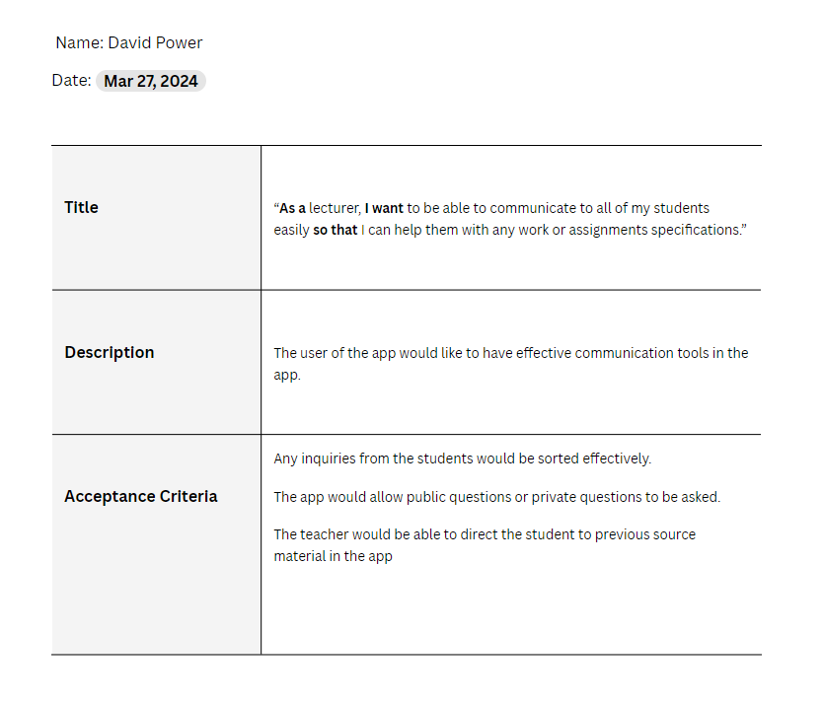

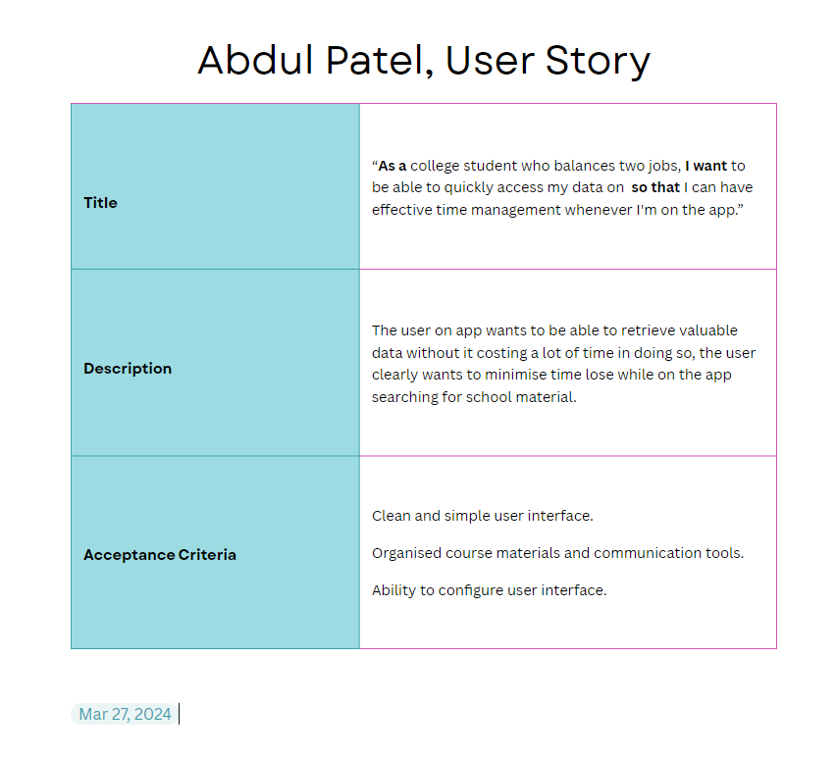

Joshua Webster – User Story

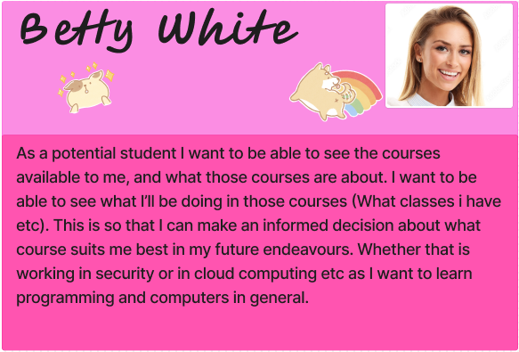
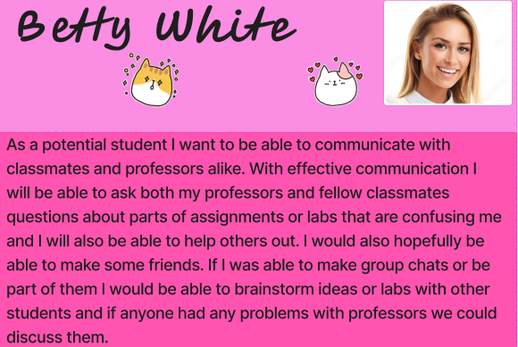

Stephen Mc Grath – User Story

As a student, I want to be able to see all information for my timetables, exam information, notices from the college or lecturers and more in one central location. Other services I have used have had multiple redirects and unclear interfaces, causing confusion and incovenience for me, which I would prefer not to have to deal with during my time at college.

As a student, I want to be able to easily instantly message lecturers and classmates. I want to be able to set up group messaging with classmates to organise assignments and group work. It can be difficult to find contact information and get in contact with lecturers quickly, as platforms like Moodle impose a cooldown before a message is actually sent. Having easy instant messaging would eliminate these problems.

